**Basin-scale model**

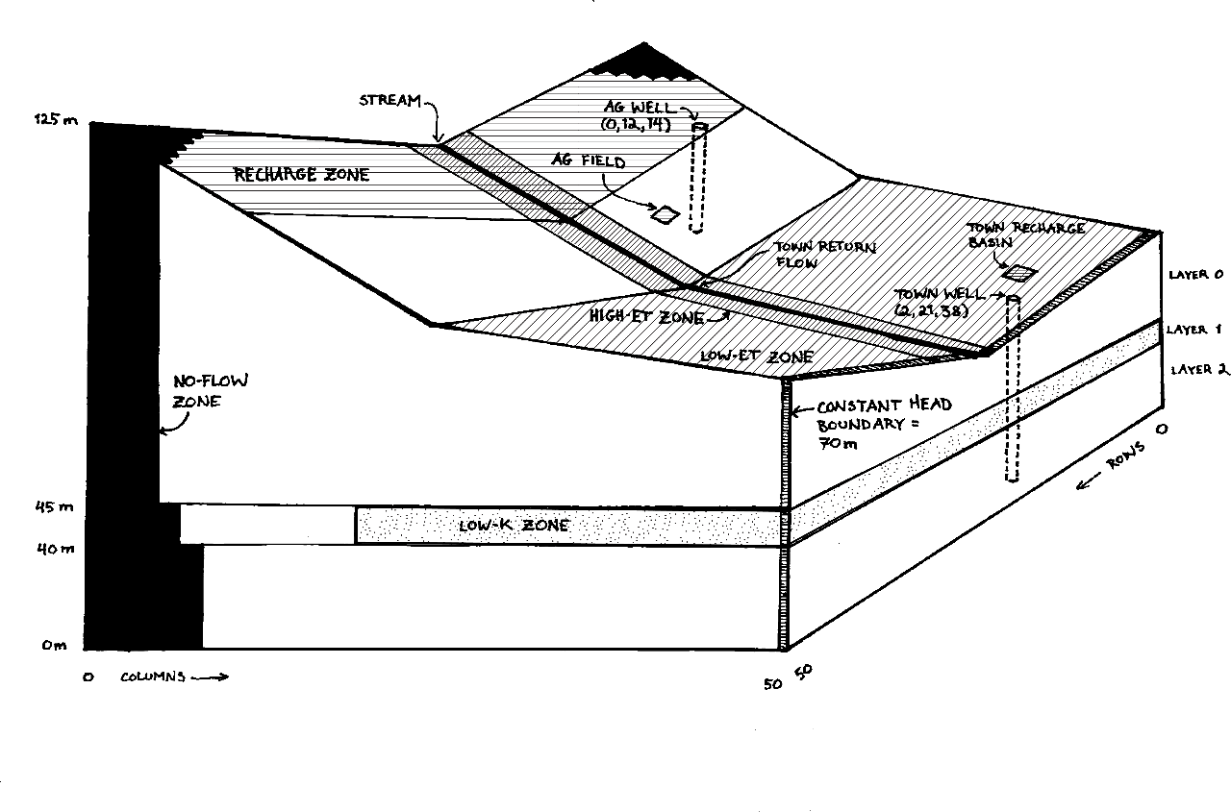

Figure 1: Conceptual model of the hypothetical watershed (Chloe Fandel).

Table 1: Physical parameters describing the base model.

|  |  |  |  |  |  |  |  |
| --- | --- | --- | --- | --- | --- | --- | --- |
| PRE-DEVELOPMENT INFLOWS & OUTFLOWS | |  | MEDIUM PROPERTIES |  |  | TOWN |  |
| Hill recharge rate  (RH) (col. 1-15) | 1.22e-5 m/day |  | Background hydraulic conductivity in all directions (Kxy) | 8.5 m/day |  | Town wastewater use ratio (recharge vs. return) | 0.25 |
| Valley evapotranspiration rate  (ETV) (col. 26-50) | 0.87e-5 m/day |  | Lower vertical hydraulic conductivity  (Kz) (layer 1, col. 21-50) | 2.1e2 × Kxy m/day |  | Town recharge basin location (NW corner) | (29,19) |
| Riparian evapotranspiration rate (ETR) (rows 23-29) | 2.076 × ETV m/day |  | Porosity (ϕ) | 0.1 |  | Town return flow location (col.) | 25 |
| ET extinction depth  (hext) (all areas with ET) | 1 m |  | Specific yield (Sy) | 0.884 |  | Town well pumping rate (QT) (layer 2, row 21, col. 38) | 1810 m3/day |
|  |  |  | Storage coefficient (Ss) | 1e-4 |  |  |  |
|  |  |  |  |  |  |  |  |
| STREAM |  |  | AGRICULTURE |  |  |  |  |
| Streambed width & thickness  (wstr) (row 26) | 1 m |  | Agricultural field location  (NW corner) | (20,19) |  |  |  |
| Streambed elevation (zstr) | 1 m below land |  | Agricultural well location  (layer, row, col.) | (0,11,13) |  |  |  |
| Stream stage (Hstr) | 0.5 m above bed |  | Field size (AA)  (only 1/8th of area active at a time) | 2 km2 |  |  |  |
| Streambed hydraulic conductivity (Kstr) | 1.36 × Kxy m/day |  | Crop demand  (for pistachios) | 6e-3 m/day |  |  |  |
| Streambed slope (mstr) | 0.001 |  | Agricultural well pumping rate (QA)  (layer 0, row 12, col. 14) | Crop demand + 50% |  |  |  |
| Streambed roughness (Rostr) | 0.04 |  | Agricultural recharge rate (ReA)  (field location and entire area) | 20% of crop demand |  |  |  |

The BIG CHALLENGE

For those of you who are feeling up for a big challenge, here it is. The second half of this course is going to center around a basin-scale model. You will be provided with a working version of this model in a few weeks. But, you are invited to start building it on your own, now! You won’t have learned all of the flopy packages necessary, yet. But, you can start building the model and add packages as you learn them … or you can learn them on your own.

This is a simple model … but, this is not a simple task at this point in your modeling career. One thing is certain, though. You will learn a LOT more about modeling if you at least try to build this model yourself before adopting the version that is provided to you!

I recommend that you start with a clean notebook. The first thing to do is to Add markdown cells to describe what you will define at each step. Generally follow the order in the starter codes that you have been given. But, I would NOT recommend numbering the sections … it just makes it a pain to insert things later. Also write down the values that you will assign for each variable. Once you have the entire workflow laid out – including those things that you don’t know how to do, yet, start building your flopy model.

Here is the modeling task:

Build a steady state model. The model should have 50x50 cells, each 1000 m in x and in y. The porosity is 0.10, specific yield is 0.10, and storage coefficient is 0.0001. There are three layers. The medium is homogeneous within each layer. The K of the top and bottom layers is 10 m/day in all three principal directions. K of the middle layer is the same as the lower layer in the leftmost 20 columns, but it is 0.0001 m/day in the z direction in the remaining columns. The bottom of the domain is topographically flat and the bottom layer is 40 m thick. The middle layer is 5 m thick and is also flat. The top layer elevation is provided in BASE_TOP_ELEV.CSV. The top left (here, left refers to the plan view – the end where the elevation is highest – top is also in plan view) and bottom left corners of the domain are 'rounded' by bedrock. Specifically, in the top, there is a triangle of no flow cells extending from row 45, column 1 to row 50, column 6, inclusive, comprising a total of 21 no flow cells. There is a symmetric no flow region in the top left corner. The middle layer has similar regions extending from row 43, column 1 to row 50, column 8. The bottom layer: row 41, column 1 to row 50, column 10.

The right boundary in all of the layers has a constant head of 70 m relative to the datum, which is located at the bottom of the domain. All other boundaries are no flow.

Recharge occurs at a rate of 4E-5 m/day in the leftmost 15 columns and is zero elsewhere. (Here, columns refer to the plan view. The left of the domain is column 1; the top of the domain is row 1. These are MODFLOW references, not python references.)

A stream extends from the left to the right boundary in row 26. The stream width, length, and thickness are 1. No flow is entering the stream (from tributaries). The K of the streambed is 1000 m/day. The roughness is 0.04 and the slope is 0.001. The streambed elevation is one m below ground surface and the stage is 0.5 m. The stream is a 'weak sink' with a strength of 0.5, meaning that half of the particles that enter a stream cell are captured by the stream.

ET is zero in the left half of the domain. ET is 1E-5 m/day in the right half of the domain. ET occurs at a rate of 5E-4 m/day in a riparian area that extends from the left boundary to the right boundary and occupies rows 23 to 29, inclusive. The extinction depth is 1 m everywhere.

There is a well that is used for water supply by the local community, which is completed in the bottom layer at row 21 and column 38. It is pumped at a rate of 1500 m3/day. The town returns some treated water to the stream at column 25.

The description above defines the system before a proposed new agricultural is added. The field is proposed to cover a 2000 m by 2000 m area; 1/8th of the area will be irrigated agriculture at any time. (Model this as uniform irrigation in time at 1/8th of the rate.) The rectangular irrigated fields extend between rows 21 and 22 (inclusive) and columns 19 and 20 (inclusive).

ET for the crop is zero - it is accounted for in the calculated recharge beneath the field. The recharge rate is assumed to be 20% of the water demand of the crop, representing intentional excess irrigation to avoid soil salinization. The water uses of wheat, pistachios, and cotton on a daily basis are: 0.004; 0.006; and 0.008 m/day. This leads to recharge rates of (e.g. 0.004 * 0.125 * 0.2 = 0.0001): 0.0001, 0.00015, and 0.0002 m/day for these crops, respectively.

Water is provided for irrigation from a well that is completed in the top layer at row 12 and column 14. The pumping rate is equal to the crop water demand plus 20% for excess irrigation plus 30% for irrigation inefficiency. For wheat, pistachios, and cotton, the pumping rates are (e.g. 0.004 *0.125 * 1.5 * 2000 * 2000 = 3000 m3/day): 3000; 4500; and 6000 m3/day.

You are asked to model three time conditions.

PART I: PRE-DEVELOPMENT

Build the base model as described above without the proposed agricultural activity. Run the model as steady state with no pumping from the town's well. This is your pre-development model. It is referred to as No Town, No Ag (NTNA).

PART II: POST-DEVELOPMENT (CURRENT)

Build the base model as described above with the town well pumping. This is referred to as Yes Town, No Ag (YTNA).

PART III: POST-AGRICULTURE (FUTURE)

Add the proposed agricultural element (pumping and localized recharge). This will be called YTYA, Yes Town, Yes Ag.